**SUPPLEMENTARY MATERIAL FOR “**Soil nitrogen availability indirectly modifies leaf nitrogen content through reductions in the unit cost of resource use”

*Calculations for soil water holding capacity*

Water holding capacity (θWHC; mm) was calculated as a function of the volumetric soil water storage at field capacity, *W*PWP (m3 m-3), and the volumetric soil water storage at wilting point:

$θ_{WHC}=\left(W_{FC}-W_{PWP}\right)\left(1-f_{gravel}\right)*min⁡\{z_{bedrock}, z_{max}\}$ (S1)

where *W*FC (m3 m-3) is the volumetric soil water storage at field capacity, *W*PWP (m3 m-3) is the volumetric soil water storage at wilting point, *f*gravel (%) is the fraction of gravel content in soil, *z*bedrock (mm) is the distance to bedrock, and *z*max (mm) is the maximum allowable distance to bedrock, set to 2000mm. *W*FC is calculated as:

$W_{FC}=k_{fc}+(1.283*{\left(k_{fc}\right)}^{2}-0.374*k_{fc}-0.015$ (S2)

where

$k_{fc}=-0.251*f_{sand}+0.195*f_{clay}+0.011*f_{OM}+0.006+0.006*\left(f_{sand}*f_{OM}\right)-0.027*\left(f_{clay}*f_{OM}\right)+0.452*\left(f_{sand}*f_{clay}\right)+0.299$ (S3)

*W*PWP is calculated as:

$W_{PWP}=k_{pwp}+(0.14*k_{pwp}-0.02)$ (S4)

where

$k_{pwp}=-0.024*f_{sand}+0.487*f_{clay}+0.006*f_{OM}+0.005*\left(f_{sand}*f_{OM}\right)-0.013*\left(f_{clay}*f_{OM}\right)+0.068*\left(f_{sand}*f_{clay}\right)+0.031$ (S5)

In Equations (S3) and (S5), *f*sand (%) is the fraction of sand content in soil (%), *f*clay (%) is the fraction of clay content in soil (%), and *f*OM is the fraction of organic matter in soil (%). Organic matter in the soil was calculated in this study by converting soil organic carbon data extracted from SoilGrids 2.0 to soil organic matter using the van Bemmelen factor (1.724 conversion factor.

**Table S1** List of sampled species, including the NRCS symbol, photosynthetic pathway, growth duration, growth habit, N fixation capability, assigned plant functional group, and the number of collected individuals

|  |  |  |  |  |  |  |  |
| --- | --- | --- | --- | --- | --- | --- | --- |
| **Symbol** | **Species** | **Photosynthetic pathway** | **Growth duration** | **Growth habit** | **N-fixer?** | **Plant functional group** | **Number sampled** |
| ACAN11 | *Acaciella angustissima* (Mill) Britton & Rose | c3 | perennial | forb, subshrub | yes | c3_legume | 3 |
| AMAR2 | *Ambrosia artemisiifolia* L. | c3 | annual | forb | no | c3_nonlegume | 25 |
| AMPS | *Ambrosia psilostachya* DC. | c3 | perennial | forb | no | c3_nonlegume | 32 |
| ARAL3 | *Argemone albiflora* Hornem. | c3 | annual | forb | no | c3_nonlegume | 3 |
| ARPU9 | *Aristida purpurea* Nutt. | c4 | perennial | graminoid | no | c4_nonlegume | 2 |
| ASAS | *Asclepias asperula* (Decne.) Woodson | c3 | perennial | forb | no | c3_nonlegume | 3 |
| ASLA4 | *Asclepias latifolia* (Torr.) Raf. | c3 | perennial | forb | no | c3_nonlegume | 3 |
| ASSY | *Asclepias syriaca* L. | c3 | perennial | forb | no | c3_nonlegume | 18 |
| BASA | *Baccharis salicina* Torr. & A. Gray | c3 | perennial | shrub | no | c3_nonlegume | 3 |
| BOIS | *Bothriochloa ischaemum* (L.) Keng | c4 | perennial | graminoid | no | c4_nonlegume | 6 |
| BOSA | *Bothriochloa saccharoides* (Sw.) Rydb. | c4 | perennial | graminoid | no | c4_nonlegume | 6 |
| CAAM2 | *Callicarpa americana* L. | c3 | perennial | shrub | no | c3_nonlegume | 3 |
| CAPL3 | *Carex planostachys* Kunze | c4 | perennial | graminoid | no | c4_nonlegume | 3 |
| CAREX | *Carex spp.* L. | c4 | perennial | graminoid | no | c4_nonlegume | 16 |
| CHFE3 | *Chamaesyce fendleri* (Torr. & A. Gray) Small | c3 | perennial | forb | no | c3_nonlegume | 2 |
| CHPI8 | *Chyrysopsis pilosa* Nutt. | c3 | annual | forb | no | c3_nonlegume | 3 |
| COCO13 | *Conoclinium coelestinum* (L.) DC. | c3 | perennial | forb | no | c3_nonlegume | 3 |
| COER | *Commelina erecta* L. | c3 | perennial | forb | no | c3_nonlegume | 3 |
| CRGLL | *Croton glandulosus* L. | c3 | annual | forb | no | c3_nonlegume | 22 |
| CYDA | *Cynodon dactylon* (L.) Pers. | c4 | perennial | graminoid | no | c4_nonlegume | 15 |
| DATE3 | *Dasylirion texanum* Scheele | c3 | perennial | shrub | no | c3_nonlegume | 3 |
| DIAN | *Dichanthium annulatum* (Forssk.) Stapf | c4 | perennial | graminoid | no | c4_nonlegume | 8 |
| ENPE4 | *Engelmannia peristenia* (Raf.) Goodman & C.A. Lawson | c3 | perennial | forb | no | c3_nonlegume | 6 |

|  |  |  |  |  |  |  |  |
| --- | --- | --- | --- | --- | --- | --- | --- |
| **Symbol** | **Species** | **Photosynthetic pathway** | **Growth duration** | **Growth habit** | **N-fixer?** | **Plant functional group** | **Number sampled** |
| EUMA8 | *Euphorbia marginata* Pursh | c3 | annual | forb | no | c3_nonlegume | 6 |
| GAPU | *Gaillardia pulchella* Foug. | c3 | annual | forb | no | c3_nonlegume | 16 |
| GLGO | *Glandularia gooddingii* (Briq.) Solbrig | c3 | perennial | forb | no | c3_nonlegume | 2 |
| HEAN3 | *Helianthus annuus* L. | c3 | annual | forb | no | c3_nonlegume | 6 |
| HECA8 | *Heterotheca canescens* (DC.) Shinners | c3 | perennial | forb | no | c3_nonlegume | 2 |
| HETE3 | *Heliotropium tenellum* (Nutt.) Torr | c3 | annual | forb | no | c3_nonlegume | 3 |
| IVAX | *Iva axillaris* Pursh | c3 | perennial | forb | no | c3_nonlegume | 4 |
| LIAT | *Lilaeopsis attenuata* auct. non (Hook. & Arn.) Fernald | c3 | perennial | forb | no | c3_nonlegume | 3 |
| LIPU | *Liatris punctata* Hook. | c3 | perennial | forb | no | c3_nonlegume | 3 |
| LOPE | *Lolium perenne* L. | c3 | perennial | graminoid | no | c3_nonlegume | 9 |
| MIQU2 | *Mimosa quadrivalvis* L. | c3 | perennial | forb | yes | c3_legume | 15 |
| NALE3 | *Nassella leucotricha* (Trin. & Rupr.) Pohl | c3 | perennial | graminoid | no | c3_nonlegume | 19 |
| OECU2 | *Oenothera curtiflora* W.L. Wagner & Hoch | c3 | annual | forb | no | c3_nonlegume | 3 |
| OENOT | *Oenothera spp.* L. | c3 | annual | forb | no | c3_nonlegume | 1 |
| PAVI2 | *Panicum virgatum* L. | c4 | perennial | graminoid | no | c4_nonlegume | 12 |
| PRGL2 | *Prosopis glandulosa* Torr. | c3 | perennial | shrub | yes | c3_legume | 33 |
| QUHA3 | *Quercus harvardii* Rydb. | c3 | perennial | shrub | no | c3_nonlegume | 3 |
| QUMO | *Quercus mohriana* Buckley ex Rydb. | c3 | perennial | shrub | no | c3_nonlegume | 1 |
| RACO3 | *Ratibida columnifera* (Nutt) Wooton & Standl. | c3 | perennial | forb | no | c3_nonlegume | 40 |
| RHAM | *Rhamnus spp.* L. | c3 | perennial | shrub | yes | c3_legume | 1 |
| RHSET | *Rhynchosia senna* Gillies ex Hook. var. *texana* (Torr. & A. Gray) M.C. Johnst. | c3 | perennial | forb | yes | c3_legume | 1 |
| RUHI2 | *Rudbeckia hirta* L. | c3 | perennial | forb | no | c3_nonlegume | 3 |
| RUNU | *Ruellia nudiflora* (Engelm. & A. Gray) Urb. | c3 | perennial | forb | no | c3_nonlegume | 15 |
| RUTR | *Rubus trivialis* Michx. | c3 | perennial | vine | no | c3_nonlegume | 3 |

|  |  |  |  |  |  |  |  |
| --- | --- | --- | --- | --- | --- | --- | --- |
| **Symbol** | **Species** | **Photosynthetic pathway** | **Growth duration** | **Growth habit** | **N-fixer?** | **Plant functional group** | **Number sampled** |
| SAFA2 | *Salvia farinacea* Benth. | c3 | perennial | forb | no | c3_nonlegume | 7 |
| SCHIZ4 | *Schizachyrium spp.* Nees | c4 | perennial | graminoid | no | c4_nonlegume | 8 |
| SCSC | *Schizachyrium scoparium* (Michx.) Nash | c4 | perennial | graminoid | no | c4_nonlegume | 3 |
| SODI | *Solanum dimidiatum* Raf. | c3 | perennial | forb | no | c3_nonlegume | 1 |
| SOEL | *Solanum elaeagnifolium* Cav. | c3 | perennial | forb | no | c3_nonlegume | 53 |
| SOHA | *Sorghum halapense* (L.) Pers. | c4 | perennial | graminoid | no | c4_nonlegume | 38 |
| STTE3 | *Stillingia texana* I.M. Johnst. | c3 | perennial | forb | no | c3_nonlegume | 3 |
| VEOC | *Verbesina occidentalis* (L.) Walter | c3 | perennial | forb | no | c3_nonlegume | 3 |
| VEST | *Verbena stricta* Vent. | c3 | perennial | forb | no | c3_nonlegume | 3 |
| WEAC | *Wedelia acapulcensis* Kunth | c3 | perennial | shrub | no | c3_nonlegume | 6 |

**Table S2** Model selection results for soil moisture, air temperature, and vapor pressure deficit. Soil moisture was used in a bivariate regression against *β*, while air temperature and vapor pressure deficit were used in bivariate regressions against *χ*\*

|  |  |  |  |  |  |  |
| --- | --- | --- | --- | --- | --- | --- |
|  | **Soil moisture** | | **Air temperature** | | **VPD** | |
| Day | AICc | RMSE | AICc | RMSE | AICc | RMSE |
| 1 | 1275.38 | 0.8163 | -871.59 | 0.0737 | -867.39 | 0.0741 |
| 2 | 1274.11 | 0.8151 | -875.38 | 0.0734 | -865.95 | 0.0742 |
| 3 | **1274.03** | **0.8150** | -873.81 | 0.0736 | -864.97 | 0.0743 |
| 4 | 1274.55 | 0.8156 | **-875.89** | **0.0737** | **-879.37** | **0.0733** |
| 5 | 1275.44 | 0.8166 | -869.65 | 0.074 | -866.19 | 0.0741 |
| 6 | 1275.98 | 0.8172 | -868.85 | 0.074 | -866.20 | 0.0741 |
| 7 | 1276.51 | 0.8177 | -867.97 | 0.0741 | -865.72 | 0.0742 |
| 8 | 1277.08 | 0.8183 | -866.51 | 0.0742 | -865.36 | 0.0742 |
| 9 | 1277.94 | 0.8192 | -866.00 | 0.0743 | -864.76 | 0.0742 |
| 10 | 1278.96 | 0.8203 | -865.65 | 0.0743 | -864.45 | 0.0743 |
| 15 | 1282.15 | 0.8240 | -866.34 | 0.0742 | -863.95 | 0.0743 |
| 20 | 1285.43 | 0.8277 | -866.64 | 0.0742 | -865.15 | 0.0743 |
| 30 | 1288.13 | 0.8307 | -866.13 | 0.0742 | -867.57 | 0.0741 |
| 60 | 1288.93 | 0.8322 | -866.20 | 0.0742 | -870.30 | 0.0739 |
| 90 | 1289.28 | 0.8323 | -866.02 | 0.0743 | -870.98 | 0.0738 |

*Timescale that conferred lowest AICc value is indicated in bold.

**Figure S2**

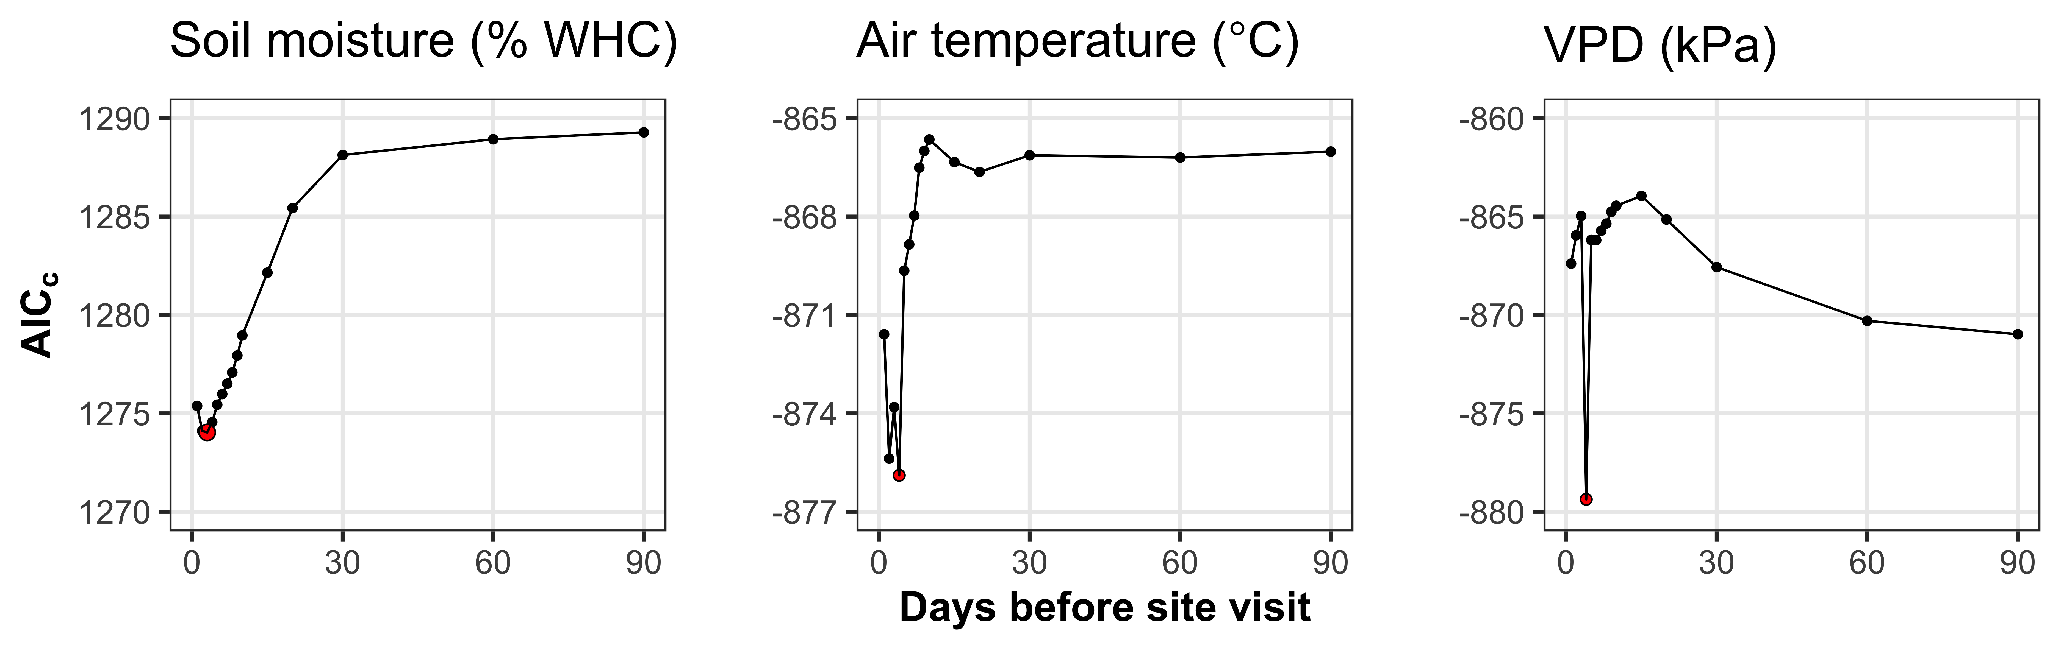

**Fig. S2** Model selection results exploring relevant timescales for soil moisture (left panel), air temperature (middle panel), and vapor pressure deficit (right panel). The x-axis indicates the number of days before each site visit and the y-axis notes the corrected Akaike Information Criterion value. The timescale with the lowest AICc value, and therefore most relevant timescale to include in statistical models, is noted as a red point.

**Figure S3**



**Figure S4**

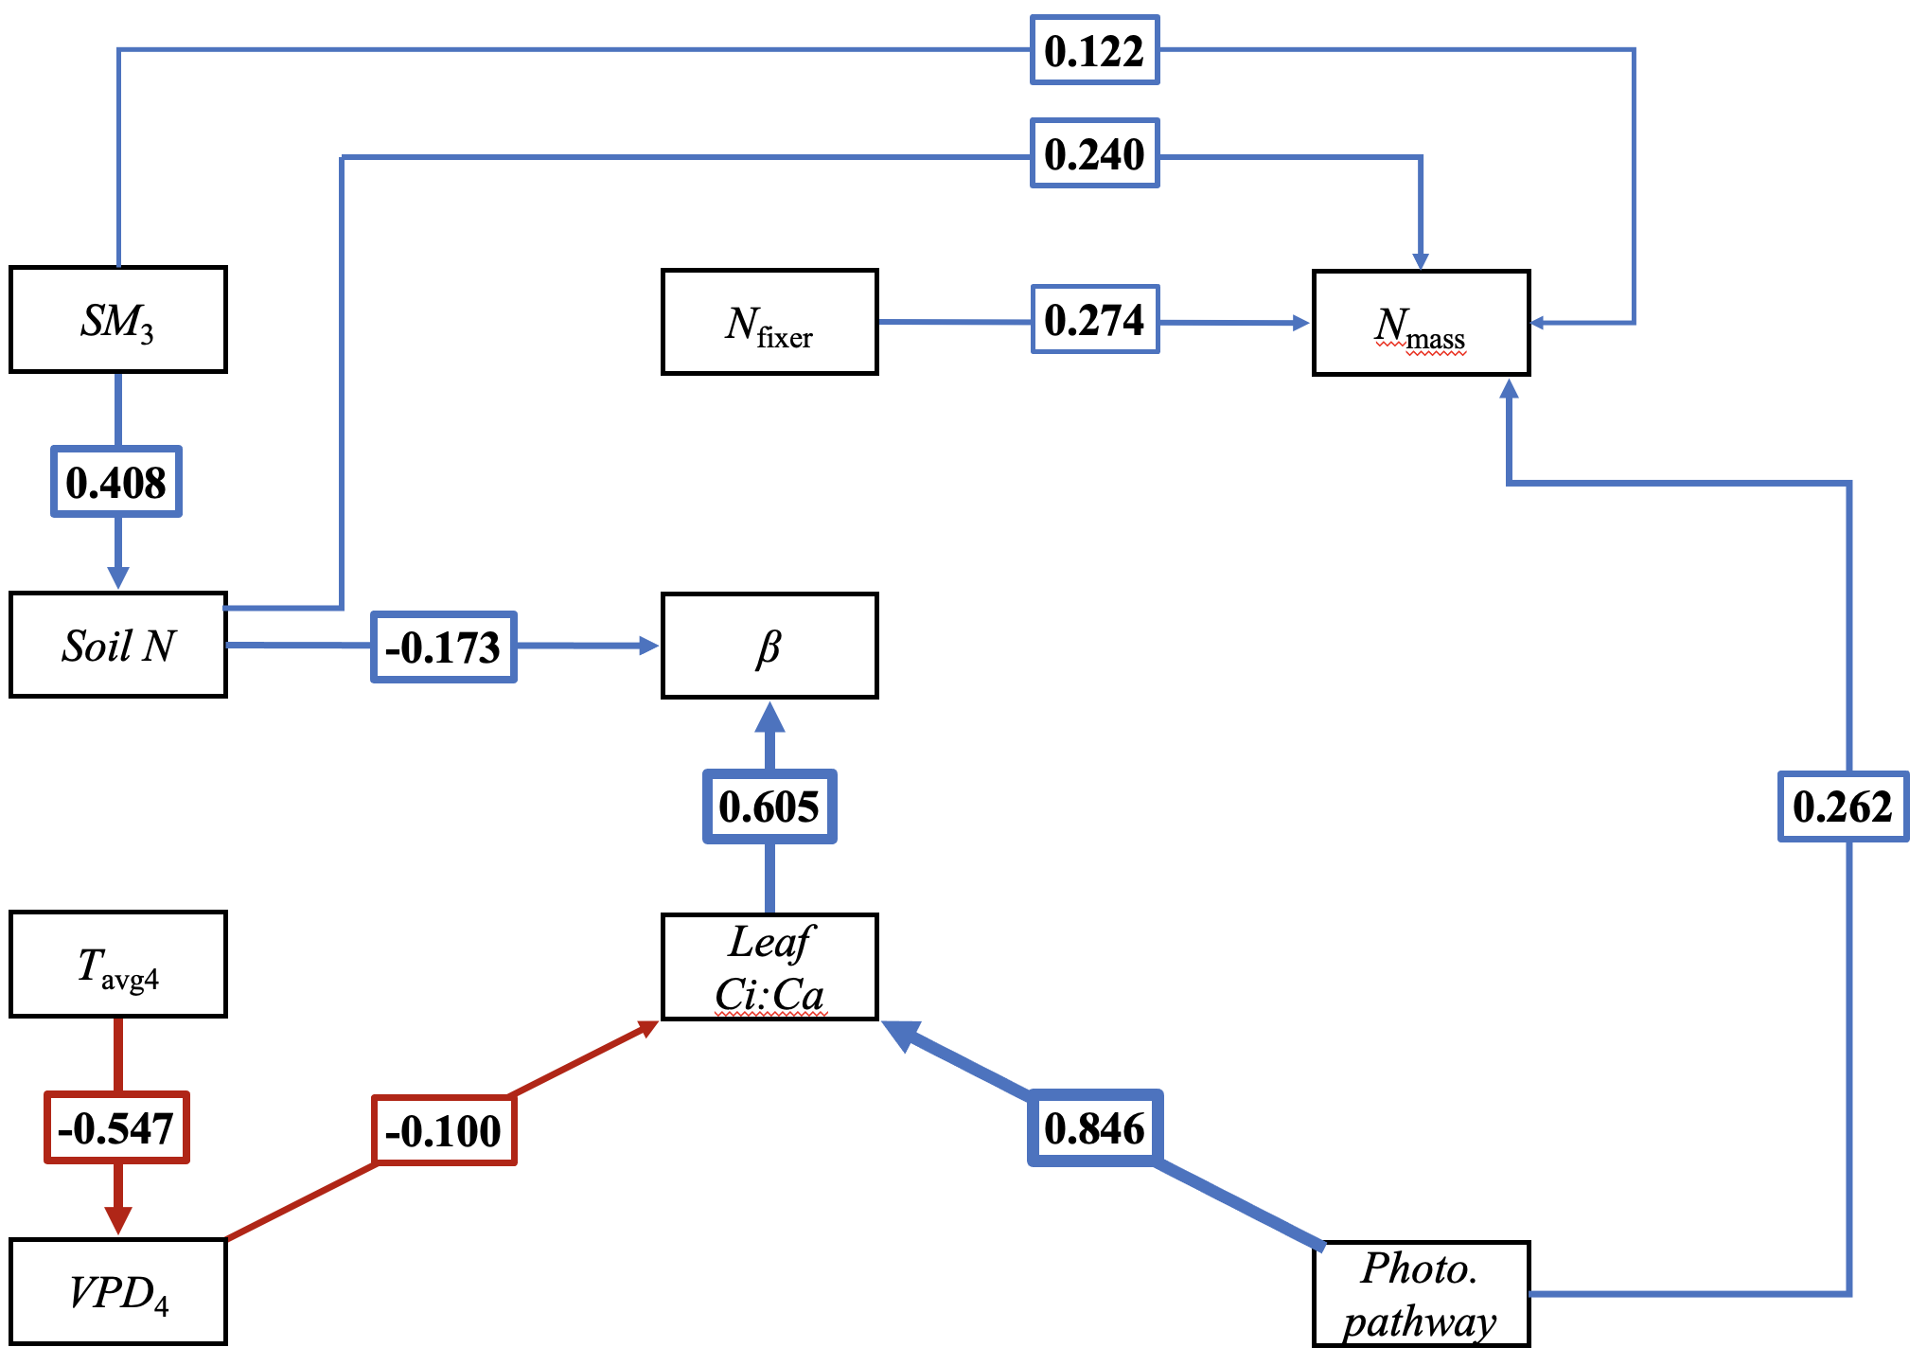

**Figure S4** Structural equation model results exploring direct and indirect drivers of leaf nitrogen content per leaf biomass. Boxes indicate measured edaphic factors, climatic factors, and leaf traits. Positively correlated bivariate relationships (p<0.05) are indicated through blue solid arrows, while negatively correlated relationships (p<0.05) are indicated through red solid arrows. Numbers inside boxes indicate standardized model coefficients of each relationship, while arrow thickness scales with the absolute value of the model coefficient.

**Figure S5**

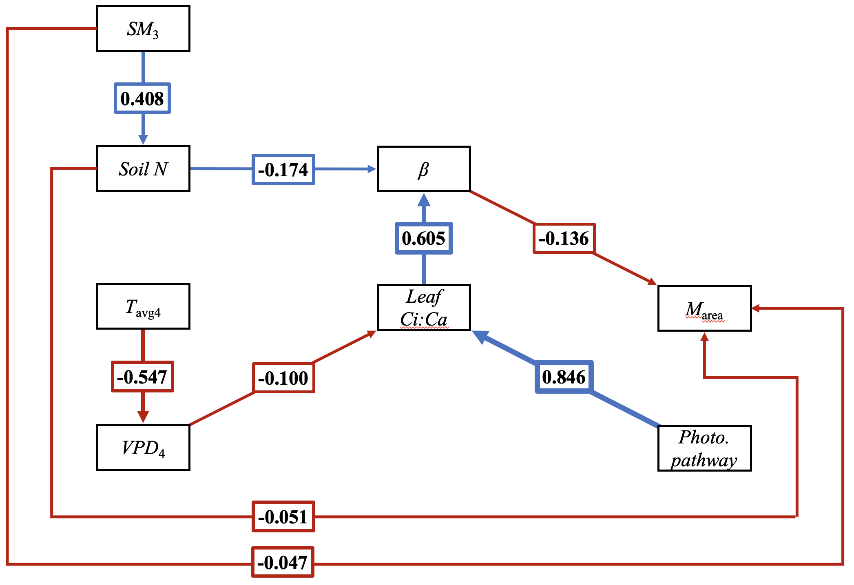

**Figure S5** Structural equation model results exploring direct and indirect drivers of leaf mass per area. Boxes indicate measured edaphic factors, climatic factors, and leaf traits. Positively correlated bivariate relationships (p<0.05) are indicated through blue solid arrows, while negatively correlated relationships (p<0.05) are indicated through red solid arrows. Numbers inside boxes indicate standardized model coefficients of each relationship, while arrow thickness scales with the absolute value of the model coefficient.